# Using a Custom Palette

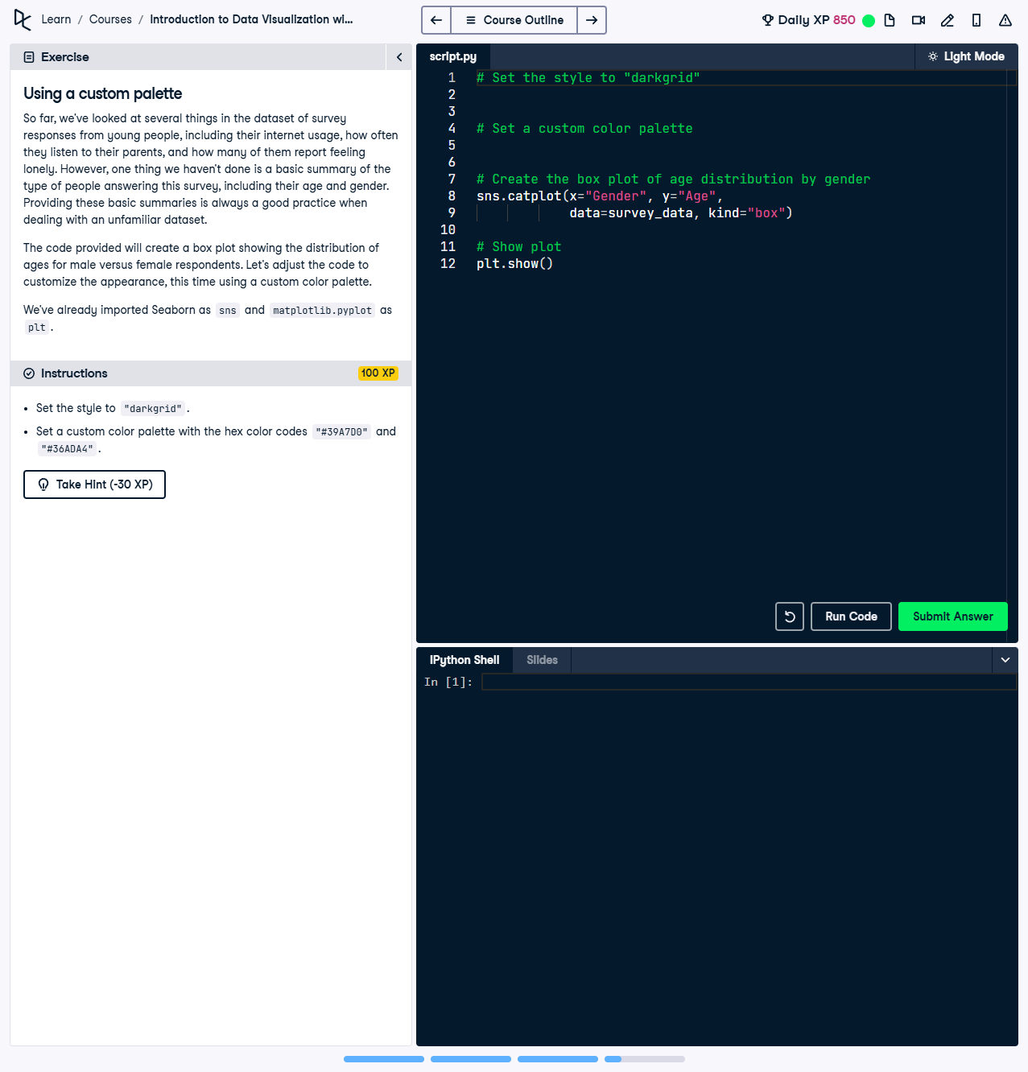

Figure 1: Screenshot showing the custom palette setup and instructions.

## Question

In this exercise, we looked at several things in the dataset of survey responses from young people, including their Internet usage, how often they listen to their parents, and how many of them report feeling lonely. However, one thing we haven't done is a basic summary of the type of people answering this survey, including their age and gender. Providing these basic summaries is always a good practice when dealing with an unfamiliar dataset.  
  
The code provided will create a box plot showing the distribution of ages for male versus female respondents. Let's adjust the code to customize the appearance, this time using a custom color palette.  
  
Instructions:  
1. Set the style to "darkgrid".  
2. Set a custom color palette with the hex color codes "#39A7D0" and "#36ADA4".

### Question Explanation

The question focuses on customizing the visual appearance of Seaborn plots by changing the style and applying a custom color palette. This exercise combines visual customization with data summarization through a box plot.

## Code Solution

# Set the style to "darkgrid"  
sns.set_style("darkgrid")  
  
# Set a custom color palette  
custom_palette = ["#39A7D0", "#36ADA4"]  
sns.set_palette(custom_palette)  
  
# Create the box plot of age distribution by gender  
sns.catplot(x="Gender", y="Age",  
 data=survey_data, kind="box")  
  
# Show plot  
plt.show()

### Answer Explanation

1. sns.set_style("darkgrid"):  
 This sets the background style of the plot to "darkgrid" for improved visibility.  
  
2. sns.set_palette(["#39A7D0", "#36ADA4"]):  
 A custom color palette is applied, with the specified hex codes representing colors for male and female respondents.  
  
3. sns.catplot():  
 - x="Gender": Groups the data by gender on the x-axis.  
 - y="Age": Displays the distribution of ages on the y-axis.  
 - kind="box": Specifies that the plot should be a box plot.  
  
4. plt.show():  
 Displays the final visualization, making the customization effective in the rendered plot.